FELLOWSHIP OF CHURCHES AND MINISTERS INTERNATIONAL
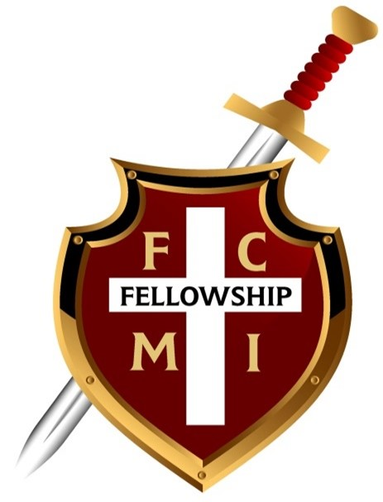
MINISTER & CHURCH AFFILIATION APPLICATION
“Together, we can make Him known.”
WELCOME TO FCMI
The Fellowship of Churches and Ministers International (FCMI) exists to bring churches and ministers of like faith and order into fellowship under the sovereign Lordship of Jesus Christ. FCMI provides a place for fellowship, encouragement, accountability, and partnership for those committed to proclaiming the Gospel of Jesus Christ.
FCMI was established in 1978 to provide a way for churches and ministers to work together in the Kingdom of God and promote the work of our Lord Jesus Christ among the nations.
WHAT FCMI PROVIDES
- Annual ministerial credentials are issued through a presbytery of ministry peers.
- Annual church credentials recognizing sound New Testament faith and practice.
- Fellowship and connection with churches and ministers of like faith and order.
- Educational Zoom meetings and monthly fellowship opportunities.
- Opportunities for theological education and discounted ministry education.
- Encouragement through monthly newsletters and shared ministry resources.
- Opportunities for writing, publishing, and developing ministry resources.
- Guidance and support from the presbytery when pastoral transitions occur.
- Opportunities for outside accountability and encouragement in ministry.
- A broader network through which members can learn what God is doing beyond their local ministry.
FCMI does not exercise ecclesiastical authority or control over its member churches or ministers, and it does not ordain ministers. Ministerial status remains a function of the local church. FCMI may issue annual credentials as an acknowledgment of a minister's moral and ethical character and soundness in Biblical doctrine, based on its knowledge and review.
SCRIPTURAL FOUNDATION
1 Corinthians 1:9 — “You were called into the fellowship of his Son, Jesus Christ our Lord.”
Romans 12:4–5 — “For just as each of us has one body with many members... so in Christ we, though many, form one body, and each member belongs to all the others.”

APPLICATION
Please complete the applicable sections below. Applications are submitted with a $50.00 fee for an individual minister or a $100.00 fee for a church/ministry organization. Applications should be completed in duplicate when required by FCMI.
☐ INDIVIDUAL MINISTER — $50.00 | ☐ CHURCH / MINISTRY — $100.00
Date: ______________________________ | Payment Received: __________________
1. APPLICANT INFORMATION
Full Name: ______________________________________________________________
Preferred Name: _________________________________________________________
Phone Number: __________________________ Email: __________________________
Home Address: ____________________________________________________________
City: ______________________________ State: __________ ZIP: ______________
2. MINISTERIAL INFORMATION
Current Ministerial Status: ☐ Ordained ☐ Licensed ☐ Other: ______________
Date Ministerial Status Granted: ___________________________________________
Church / Organization Granting or Recognizing Ministerial Status:
____________________________________________________________________________
Current Ministry / Church Name: ____________________________________________
Title / Ministry Position: __________________________________________________
Ministry Address: _________________________________________________________
City: ______________________________ State: __________ ZIP: ______________
Please indicate the church or organization that currently recognizes your ministerial status. FCMI recognizes that ministerial status is a function of the local church and is not itself responsible for ordaining or licensing ministers.
3. CHURCH / MINISTRY INFORMATION
Church / Ministry Name: __________________________________________________
Pastor / Ministry Leader: _________________________________________________
Phone: ______________________________ Email: ______________________________
Website / Social Media (optional): _________________________________________
Church / Ministry Address: _________________________________________________
City: ______________________________ State: __________ ZIP: ______________

4. FCMI COVENANT & PARTICIPATION
Please check each statement to indicate your agreement:
☐ I have reviewed the FCMI Constitution and By-Laws and agree to abide by them.
☐ I desire to participate in the fellowship and unity of the Holy Spirit and the bond of peace.
☐ I will make every reasonable effort to be an active and supportive member of FCMI.
☐ I understand that FCMI does not exercise ecclesiastical authority or control over its members.
5. SIGNATURE
By signing below, I affirm that the information provided in this application is true and complete to the best of my knowledge and that I desire to participate in the fellowship of FCMI.
Applicant Signature: __________________________________________ Date: __________________
FOR FCMI OFFICE USE ONLY
Application Received: __________________________
Fee Received: ☐ $50.00 ☐ $100.00
Reviewed By: __________________________________
Approval / Credential Date: _____________________
Notes: ____________________________________________________________________

